**1. EKS Storage - RDS DB Introduction**

--- we are going to understand about RDS DB, we will used it as underlying db instead of mysql.

**Previous architecture explanation**

--- **note** – before implementing RDS as our underlying DB. Lets look at our previous architecture.

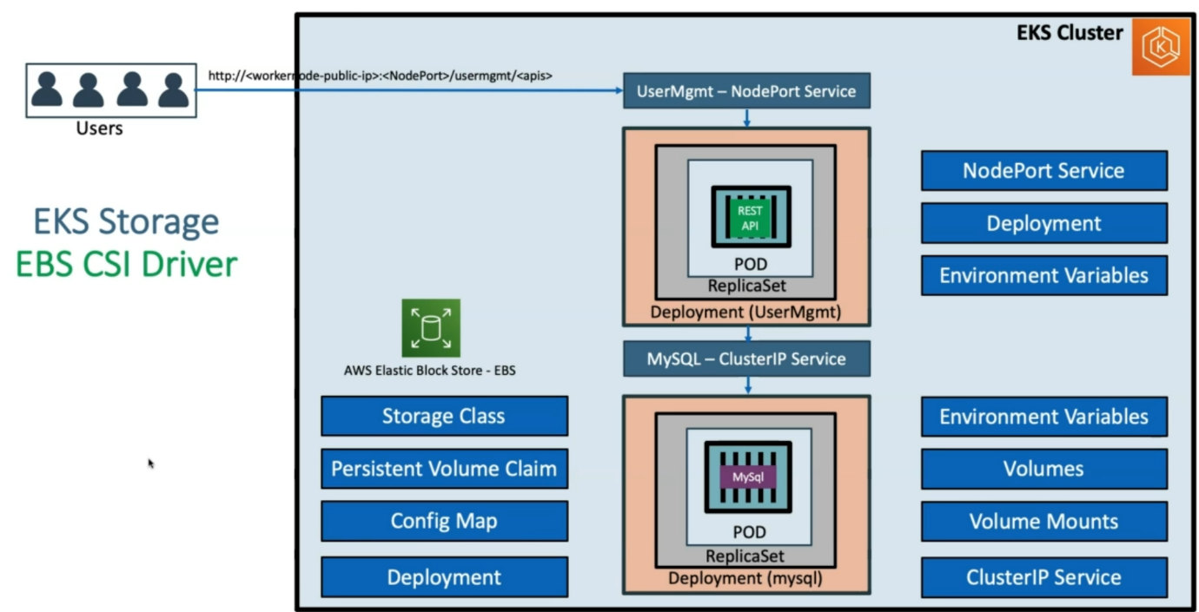

--- we used mysql container to create a pod and its equilent deployment and then we used mysql cluster ip service to expose it for our user management application. Now out user management application has mysql as a DB inside of the kubernetes cluster.

--- for persistent volumes we used the elastic block store.

--- for production grade application this architecture is not good.

**Draw backs of EBS CSI and mysql db as a pod inside of kubernetes cluster**

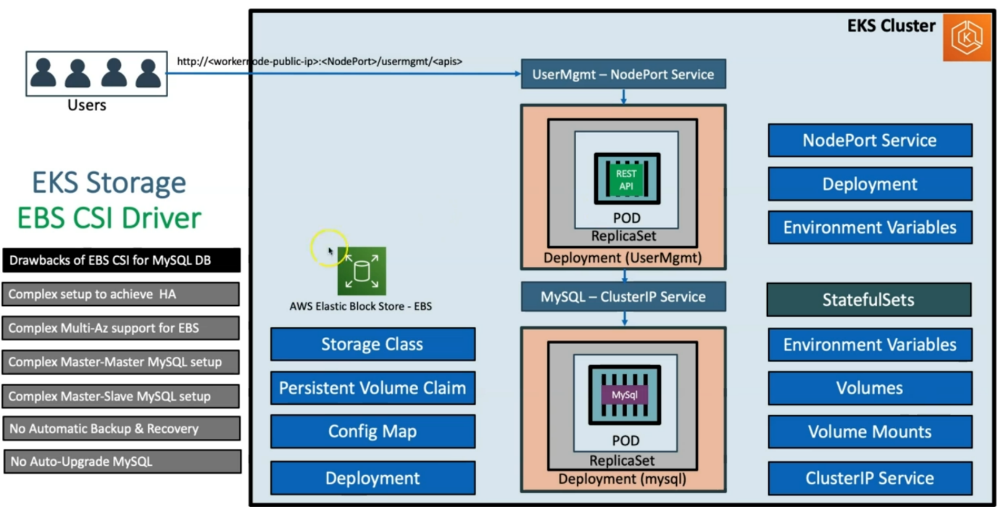

**Advantages of Amazon RDS**

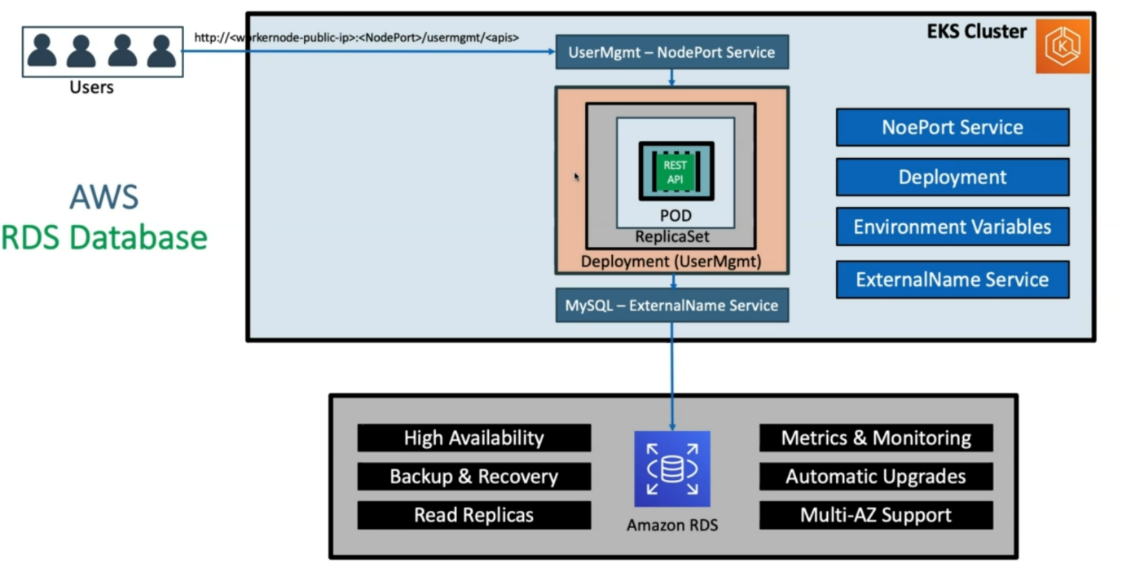

--- **note** - we remove the mysql DB and added amazon RDS as our underlying db tool. When we are using RDS, we will learn how we are going to connect RDS DB.

--- in kubernetes, there is a concept called external name service, we will use this service to connect Amazon RDS from user management service application.

--- **Advantages of Amazon RDS**:

1. High availability
2. Backup & Recovery
3. You can create any number of read replicas
4. Metrics and monitoring is available out of the box
5. Automatic upgrades, there will be minor and major upgrades. You can schedule them
6. Multi AZ support

--- **note** – we will get dns endpoint and will configure that dns in the **external name service**.

**AWS EKS network design with EKS workload & RDS Database**

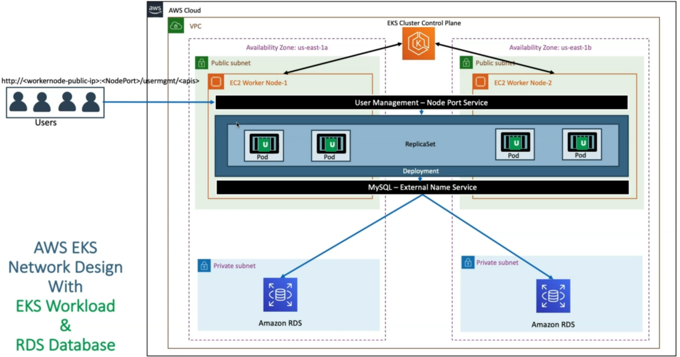

--- **note** – how the above design is looks in a vpc.

--- in AWS cloud, the vpc will be created automatically as part of the kubernetes cluster and based on the command we said that our EKS cluster should be available in **us-east-1a** and **us-east-1b**.

--- we will always create our Amazon RDS in private subnet. In addition, that we will also have public subnet

--- when EKS cluster control plane created then it will also create worker nodes in each public subnet.

--- **note** – the moment when we move into load balancer, we ensure that the worker nodes, part of the node group will move under private subnet. Only the load balancers will be present under public subnet.

--- in kubernetes cluster will crate mysql external name service, which will connect to the Amazon RDS, which will available in 2 availability zones.

--- we will deploy our user management application, which will have replicaset. We will also crate nodeport service to expose the deployment over the internet.